1
 | Mon | Tues | Wed | Thurs | Fri
WEEK 1 | 3  Waffles (WGR)  4 oz. Orange Juice  6 oz. Milk | 4  3/4 cup Cereal (WGR)  4 oz Bananas  6 oz. Milk | 5  English Muffins  4 oz Orange Juice  6 oz. Milk | 6  3/4 cup Cereal (WGR)  4 oz. Grape Juice  6 oz. Milk | 7  Muffins  4 oz. Oranges  6 oz. Milk | SUBSTITUTES:  Bread or Bread Alternative:  (Breakfast: Bread or English Muffin, Cold Cereal, Muffin)
WEEK 2 | 10  Pancakes  4 oz Orange Juice  6 oz. Milk | 11  3/4 cup Cereal (WGR)  4 oz Bananas  6 oz. Milk | 12  Croissant  4 oz Orange Juice  6 oz. Milk | 13  3/4 cup Cereal (WGR)  4 oz. Grape Juice  6 oz. Milk | 14  French Toast Sticks (WGR)  4 oz. Oranges  6 oz. Milk | (WGR)=Whole Grain Rich
WEEK 3 | 17  No School  President’s Day | 18  3/4 cup Cereal (WGR)  4 oz Orange Juice  6 oz. Milk  (Daycare Only) | 19  Bagels  4 oz. Bananas  6 oz. Milk  (Daycare Only) | 20  3/4 cup Cereal (WGR)  4 oz. Grape Juice  6 oz. Milk  (Daycare Only) | 21  Muffins  4 oz. Oranges  6 oz. Milk  (Daycare Only)
WEEK 4 | 24  Pancakes  4 oz Orange Juice  6 oz. Milk | 25  3/4 cup Cereal (WGR)  4 oz. Bananas  6 oz. Milk | 26  English Muffins  4 oz Orange Juice  6 oz. Milk | 27  3/4 cup Cereal (WGR)  4 oz. Grape Juice  6 oz. Milk | 28  Biscuits  Turkey Sausage  4 oz. Oranges  6 oz. Milk | Fruit Juice: Apple, Orange, Grape, Fresh Fruit: Oranges, Apples, Oranges, or Seasonal Fruit
WEEK 5 |  |  |  |  |  | Cereal served will be one of the following: Life, Kix, Cheerios, or Rice Krispies, or Rice Chex

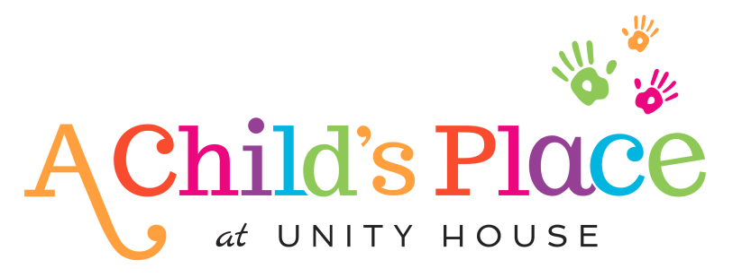

Milk Serving Size: Toddlers: ½ Cup whole milk 3-5 Years: 6 oz. 1% milk
This institution is an equal opportunity provider

