 | Mon | Tues | Wed | Thurs | Fri
WEEK 1 |  | 1  Whole Grain Lemon Bread  Or Whole Grain Pumpkin Bread  Apple Juice | 2  Pretzeks  Milk | 3  Apples  Milk | 4  String Cheese  Crackers  Apple Juice | SUBSTITUTES:  Bread or Bread Alternative:  (Breakfast: Bread or English Muffin, Cold Cereal, Muffin)(Lunch: Bread, Pasta, Rice, Noodles, Potatoes)
WEEK 2 | 7  Cheese Its (WGR)  Milk | 8  Graham Crackers  Apple Juice | 9  Whole Grain Blueberry Bread  Milk | 10  Pears  Milk | 11  Yogurt  Apple Juice
WEEK 3 | 14  Goldfish (WGR)  Milk  (Daycare Only) | 15  Whole Grain Lemon Bread  Or Whole Grain Pumpkin Bread  Apple Juice  (Daycare Only) | 16  Pretzeks  Milk  (Daycare Only) | 17  Clementines  Milk  (Daycare Only) | 18  String Cheese  Crackers  Apple Juice  (Daycare Only) | Canned Fruit: Peaches, Pears, Pineapple Chunks, Applesauce, Fruit Cocktail
WEEK 4 | 21  Cheese Its (WGR)  Milk | 22  Graham Crackers  Apple Juice | 23  Whole Grain Blueberry Bread  Milk | 24  Apples  Milk | 25  Yogurt  Apple Juice | Fruit Juice: Apple, Orange, Grape,; Fresh Fruit: Bananas, Apples, Oranges, or Seasonal Fruit
WEEK 5 | 28  Goldfish (WGR)  Milk | 29  Whole Grain Lemon Bread  Or Whole Grain Pumpkin Bread  Apple Juice | 30  Pretzeks  Milk |  |  | Meat/Meat Alternative can be: Chicken Nuggets or Chicken Patties, Fish Sticks, Hamburgers, Sandwiches
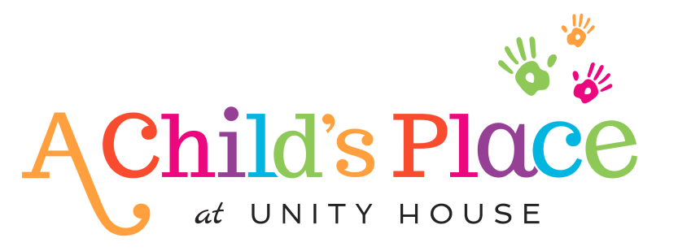

This institution is an equal opportunity provider
Milk Serving Size: Toddlers: ½ Cup whole milk 3-5 Years: 6 oz. 1% milk

