 | Mon | Tues | Wed | Thurs | Fri
WEEK 1 |  |  |  | 1  Apples  Milk | 2  String Cheese  Crackers  Apple Juice | SUBSTITUTES:  Bread or Bread Alternative:  (Breakfast: Bread or English Muffin, Cold Cereal, Muffin)(Lunch: Bread, Pasta, Rice, Noodles, Potatoes)
WEEK 2 | 5  Cheese Its (WGR)  Milk | 6  Graham Crackers  Apple Juice | 7  Whole Grain Blueberry Bread  Milk | 8  Pears  Milk | 9  Yogurt  Apple Juice
WEEK 3 | 12  Goldfish (WGR)  Milk | 13  Whole Grain Lemon Bread  Or Whole Grain Pumpkin Bread  Apple Juice | 14  Pretzeks  Milk | 15  Peaches  Milk  (Daycare Only) | 16  String Cheese  Crackers  Apple Juice | Canned Fruit: Peaches, Pears, Pineapple Chunks, Applesauce, Fruit Cocktail
WEEK 4 | 19  Cheese Its (WGR)  Milk | 20  Graham Crackers  Apple Juice | 21  Whole Grain Blueberry Bread  Milk | 22  Plums  Milk | 23  Yogurt  Apple Juice  (Daycare Only) | Fruit Juice: Apple, Orange, Grape,; Fresh Fruit: Bananas, Apples, Oranges, or Seasonal Fruit
WEEK 5 | 26  No School  Memorial Day | 27  Whole Grain Lemon Bread  Or Whole Grain Pumpkin Bread  Apple Juice | 28  Pretzeks  Milk | 29  No School  Staf fDevelopment Day | 30  String Cheese  Crackers  Apple Juice | Meat/Meat Alternative can be: Chicken Nuggets or Chicken Patties, Fish Sticks, Hamburgers, Sandwiches
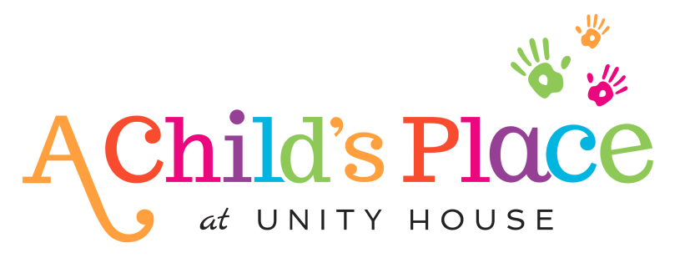

This institution is an equal opportunity provider
Milk Serving Size: Toddlers: ½ Cup whole milk 3-5 Years: 6 oz. 1% milk

